Move/Merge Nodes FEMAP Basic Program

A simple of example of an OLE/COM API Program written in and executed in the FEMAP API window.

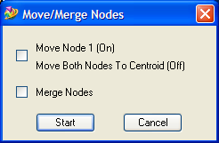 | Two simple options:  Option 1:  On – Node 1 is moved to the same location as Node 2  Off – Node 1 and Node 2 are both moved to their average location  Option 2:  On – Node 1 is merged away, with all references to it updated to Node 2  Off – Node 1 and Node 2 both remain

